Atividade 7 – C208L1

1 -) **if** ( a **==** b )

c **=** a **+** b;

a **=** b **-** c;

**else**

b **=** a **+** c;

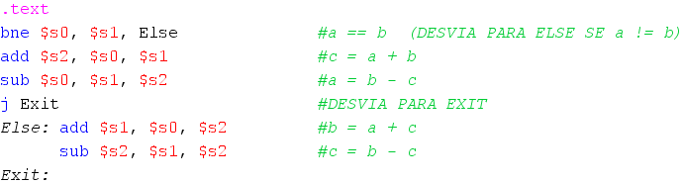 c **=** b **-** c;

2 -) **if** ( a **>=** b )

c **=** a **+** b;

a **=** b **-** c;

**else**

b **=** a **+** c;

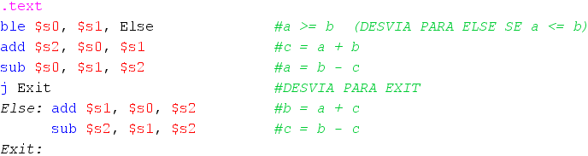 c **=** b **-** c;

3 -) **if** ( a **>** b )

c **=** a **-** b;

a **=** b **+** c;

**else**

b **=** a **-** c;

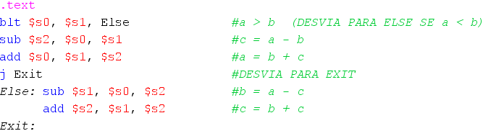 c **=** b **+** c;

4 -) **if** ( a **<** b )

c **=** a **+** b;

a **=** b **-** c;

**else**

b **=** a **+** c;

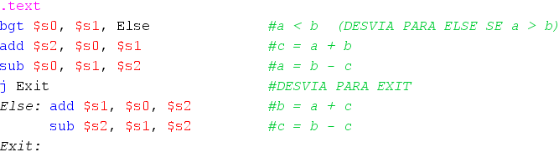 c **=** b **-** c;

5 -) int i **=** 10;

int cont **=** 0;

**while** ( i **>** 0 ) **{**

cont **+=** 5;

i **-=** 2;

